ERM Explorer
Digital
Information
tools

Accessibility Report 02/09/2022

Accessibility Test Report

Document Information

Document History
Version | Issue Date | Changes
v0.1

Document References
Document | Version
Webtoolkit.govt.nz
https://www.w3.org/TR/WCAG21/
http://webaim.org/standards/wcag/checklist
https://www.w3.org/TR/wai-aria-practices-1.2/

Document Review
Person | Role | Signature | Caveats
Giles Boutel | Manager Digital Information Tools
Mark Morrell | Senior Technical Advisor

- INTRODUCTION
  - Context
Effective 01 July 2013, the New Zealand Government Web Accessibility Standard (the Standard) replaces the Technical section of the New Zealand Government Web Standards 2.0.
While the previous NZ Government Web Standards 2.0 combined both accessibility and non-accessibility requirements, the NZ Government Web Accessibility Standard includes only accessibility-specific requirements. Other requirements unrelated to accessibility have been included in the NZ Government Web Usability Standard. Having two separate standards helps to clarify the focus and application of each, and makes it easier to update each one as required.
  - What’s required
The Standard contains one principal requirement, namely that each web page within scope must meet all five of the Web Content Accessibility Guidelines (WCAG) 2.1 conformance requirements (Level A and AA success criteria).
  - Mandated organisations
Based on a 2003 mandate established by Cabinet (Cabinet Minute (03)41/2B), all Public Service departments and Non-Public Service departments in the State Services are directed to implement the Standard.
Other State sector organisations are not required to implement the Standard, but are strongly encouraged to do so. By virtue of the legislation (i.e. Human Rights Act 1993, Bill of Rights Act 1990) and New Zealand’s ratification of the United Nations Convention on the Rights of Persons with Disabilities that underlie the requirement for mandated organisations to produce accessible websites, there is a reasonable expectation that the websites of all Government organisations will be accessible to the widest range of New Zealanders, including people with disabilities.
1.2.2 Scope
The Standard applies to two classes of web pages that are produced or maintained, in part or in whole, by New Zealand Government organisations to which this Standard applies:
- publicly available web pages that can be accessed by individuals who are not employed by a NZ Government organisation subject to the Standard. This includes web pages that require users to authenticate themselves through some kind of login, e.g. a Government extranet that restricts access to specific non-Government organisations.
- internally facing web pages that have been created, redesigned, or redeveloped since 01 July 2014, and that can be accessed only by individuals who are employed by a NZ Government organisation subject to the Standard. This includes web pages that are part of a Government organisation’s intranet.
Including internally facing web pages within the scope of the Standard is intended to help Government organisations build a work environment that is:
- more open to the employment of people with disabilities, and
- consistent with provisions generally accepted as necessary for the fair and proper treatment of employees, as identified in section 77A of the State Sector Act 1998 .
Note that the definition of web page used in this Standard includes what are typically referred to as web applications, but also resources such as MS Word and PDF documents.

- SUMMARY
  - Project testing phases
The following section documents the Accessibility testing activities that were undertaken and any issues that emerged as a result.
Accessibility testing comprises of

Testing | Description
SortSite and/or aXe report | Automated code test of the site
Contrast | Test on foreground/background colour ratios
Keyboard | Test to ensure site is keyboard navigable
NVDA | Test with Freeware Screen reader application

The following domains were tested
https://app-bldenrgy-ermx-iar-portal-ae-sit.azurewebsites.net/dashboard/

  - Out of Scope Testing items
The following items were deemed “Out of Scope” for testing for this project:
Test Type | Reason
Usability Testing | The usability standards are content issues, handled by another team.

  - Testing methodology
Testing is done to ensure websites meet WCAG 2.1 specifications to AA level.
http://www.w3.org/TR/WCAG21/
To assist in meeting these requirements, the website is tested against the following criteria
http://webaim.org/standards/wcag/checklist
https://www.w3.org/TR/wai-aria-practices-1.1/
Testing is also done against a (free, open-source) screen reader, NVDA, so that no user experiences a cost-related barrier to a working screen reading solutions. As of 2021 NVDA has a large market share (60%+).

  - Contesting Results
Most testing of this nature provides clear-cut results: A web-page is either standards conformant or not. However, in a dynamic format such as a web page, there may be rare mitigating circumstances where one interpretation of the standard is inappropriate. In this event, those receiving the report may like request reconsideration of one or more items, with a written description of their reasoning.

- TEST RESULTS
Note for the Developer:
Though most issues show a relevant link they may also be applicable to other pages/forms. Please ensure when fixing issues that they are fixed on all page/forms the issue is applicable to not just the form/page listed in the defect list below.

  - SortSite/aXe and general code issues
The following issues have been identified as non-conformant to WCAG2.1 AA http://www.w3.org/TR/WCAG21. The issues below are those that have been investigated and deemed to require attention.

Issue Number | Accessibility 1
Issue | Buttons must have discernible text
Link | https://app-bldenrgy-ermx-iar-portal-ae-sit.azurewebsites.net/dashboard/
Impact | Screen reader users are not able to discern the purpose of elements with role="link", role="button", or role="menuitem" that do not have an accessible name.
Severity | Critical
Required Correction | Ensure buttons have discernible text  Element location  .search-input > button[type="submit"]  Element source  <button type="submit">  To solve this issue, you need to...  Fix at least one (1) of these issues:  - Element does not have inner text that is visible to screen readers  - aria-label attribute does not exist or is empty  - aria-labelledby attribute does not exist, references elements that do not exist or references elements that are empty  - Element has no title attribute  - Element's default semantics were not overridden with role="none" or role="presentation"  Comment  Add ARIA label.
Search icon


Issue Number | Accessibility 2
Issue | Links must have discernible text
Link | https://app-bldenrgy-ermx-iar-portal-ae-sit.azurewebsites.net/dashboard/
Impact | Inaccessible link elements pose barriers to accessibility, as they are a fundamental component of a website.  Users who rely exclusively on a keyboard (and no mouse) to navigate a webpage can only click on links that can receive programmatic focus. A link that cannot receive programmatic focus is inaccessible to these users.  Like sighted users, screen reader users need to know where a link is pointing. Inner link text provides this information, though it won't get used if a screen reader can't access it.  Keyboard users, including visually impaired screen reader users or people who cannot use a mouse, can activate only the links and form elements that can receive programmatic focus. Any events activated exclusively by other types of focus, for example onmouseover events that depend on the mouse hover focus, are inaccessible to keyboard users. Only links and form elements receive keyboard focus by default. Modify elements that are not links or form components to receive focus by adding tabindex="0".
Severity | Major
Required Correction | Ensure links have discernible text  Element location  .logo  Element source  <a class="logo" href="/">  To solve this issue, you need to...  Fix at least one (1) of these issues:  - Element does not have text that is visible to screen readers  - aria-label attribute does not exist or is empty  - aria-labelledby attribute does not exist, references elements that do not exist or references elements that are empty  - Element has no title attribute  And  Fix the following:  Element is in tab order and does not have accessible text  Comment  All alt tag
Header logo
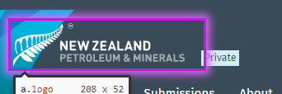
Footer follow logos


Issue Number | Accessibility 3
Issue | Images must have alternate text
Link | https://app-bldenrgy-ermx-iar-portal-ae-sit.azurewebsites.net/  https://app-bldenrgy-ermx-iar-portal-ae-sit.azurewebsites.net/dataset/?q=testing&ext_bbox=&ext_prev_extent=  https://app-bldenrgy-ermx-iar-portal-ae-sit.azurewebsites.net/survey/td-testing-publishing  Applies to all maps
Impact | Screen readers have no way of translating an image into words that gets read to the user, even if the image only consists of text. As a result, it's necessary for images to have short, descriptive alt text so screen reader users clearly understand the image's contents and purpose.  If you can't see, all types of visual information, such as images, are completely useless unless a digital text alternative is provided so that screen readers can convert that text into either sound or braille. The same is true in varying degrees for people with low vision or color-blindness.  When you do not provide an acceptable alternative that works for their available sensory modalities, such as making an image accessible by providing a digital text description, screen readers cannot convert it into speech or braille to make it available by sound or touch.
Severity | Critical
Required Correction | Ensure <img> elements have alternate text or a role of none or presentation  Element location  .leaflet-tile.leaflet-tile-loaded:nth-child(1)  Element source  <img class="leaflet-tile leaflet-tile-loaded" src="https://tile.openstreetmap.org/4/15/9.png" style="height: 256px; width: 256px; left: 110px; top: -101px;">  To solve this issue, you need to...  Fix at least one (1) of these issues:  - Element does not have an alt attribute  - aria-label attribute does not exist or is empty  - aria-labelledby attribute does not exist, references elements that do not exist or references elements that are empty  - Element has no title attribute  - Element's default semantics were not overridden with role="none" or role="presentation"  Comment  Add alt text to image letting the user know they can enter coordinates manually.
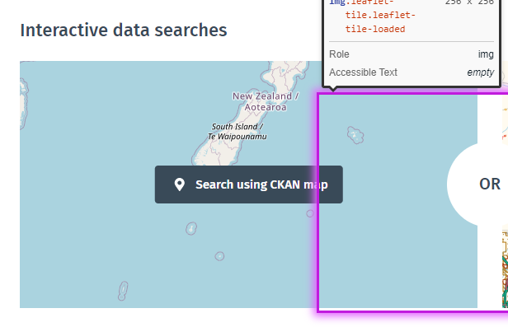
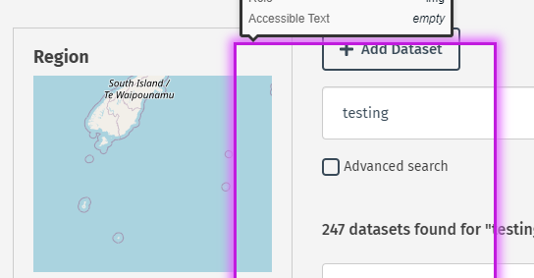
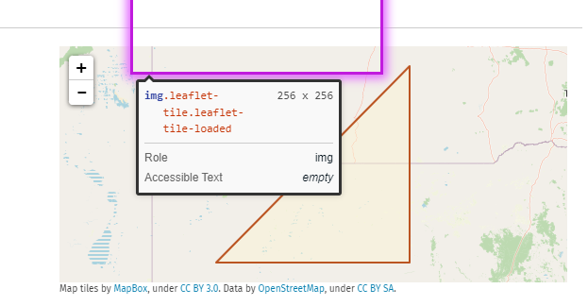

Issue Number | Accessibility 4
Issue | <ul> and <ol> must only directly contain <li>, <script> or <template> elements
Link | https://app-bldenrgy-ermx-iar-portal-ae-sit.azurewebsites.net/dataset/?q=testing&ext_bbox=&ext_prev_extent=  https://app-bldenrgy-ermx-iar-portal-ae-sit.azurewebsites.net/survey/td-testing-publishing  Applies to all select boxes
Impact | Screen readers have a specific way of announcing lists. This feature makes lists clearer to understand, but will only work if lists are properly structured.  When content elements other than list items are contained within a set of list elements, screen readers cannot inform the listener that they are listening to items within the list.  For a list to be valid, it must have both parent elements (a set of ul elements or a set of ol elements) and child elements (declared inside of these tags using the li element), and any other content elements are invalid.  Although some non-content elements such as script, template, style, meta, link, map, area, and datalist are permitted within lists, content elements other than li are not permitted.
Severity | Major
Required Correction | Ensure that lists are structured correctly  Element location  .select-options  Element source  <ul class="select-options select-options-field-order-by os-host os-theme-dark os-host-resize-disabled os-host-scrollbar-horizontal-hidden os-host-scrollbar-vertical-hidden os-host-transition" data-module="tweaks-scrollbar">  To solve this issue, you need to...  Fix the following:  List element has direct children that are not allowed inside <li> elements  Related nodes:  .os-size-auto-observer  .os-content-glue  .os-padding  Comment  UL has direct divs underneath it. Please follow standards practices for HTML lists.
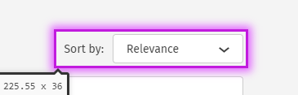

Issue Number | Accessibility 5
Issue | <li> elements must be contained in a <ul> or <ol>
Link | https://app-bldenrgy-ermx-iar-portal-ae-sit.azurewebsites.net/dataset/?q=testing&ext_bbox=&ext_prev_extent=  https://app-bldenrgy-ermx-iar-portal-ae-sit.azurewebsites.net/survey/td-testing-publishing  Applies to all select boxes
Impact | For a list to be valid, it must have both parent and child elements. Parent elements can either be a set of ul tags or a set of ol tags. Child elements must be declared inside of these tags using the li tag.  Screen readers notify users when they come to a list, and tell them how many items are in a list. Announcing the number of items in a list and the current list item helps listeners know what they are listening to, and what to expect as they listen to it.  If you don't mark up a list using proper semantic markup in a hierarchy, list items cannot inform the listener that they are listening to a list when no parent is indicating the presence of a list and the type of list.
Severity | Major
Required Correction | Ensures <li> elements are used semantically  Element location  li[data-index="0"]  Element source  <li data-index="0" data-value="score desc, metadata_modified desc" class="active">Relevance</li>  To solve this issue, you need to...  Fix the following:  List item does not have a <ul>, <ol> parent element  Comment  Ii has no OL/UL parent. Please follow standards practices for HTML lists.

Issue Number | Accessibility 6
Issue | Links must have discernible text
Link | https://app-bldenrgy-ermx-iar-portal-ae-sit.azurewebsites.net/submission
Impact | Inaccessible link elements pose barriers to accessibility, as they are a fundamental component of a website.  Users who rely exclusively on a keyboard (and no mouse) to navigate a webpage can only click on links that can receive programmatic focus. A link that cannot receive programmatic focus is inaccessible to these users.  Like sighted users, screen reader users need to know where a link is pointing. Inner link text provides this information, though it won't get used if a screen reader can't access it.  Keyboard users, including visually impaired screen reader users or people who cannot use a mouse, can activate only the links and form elements that can receive programmatic focus. Any events activated exclusively by other types of focus, for example onmouseover events that depend on the mouse hover focus, are inaccessible to keyboard users. Only links and form elements receive keyboard focus by default. Modify elements that are not links or form components to receive focus by adding tabindex="0".
Severity | Major
Required Correction | Ensure links have discernible text  Element location  li:nth-child(3) > a[href="/submission/?page=2"]  Element source  <a href="/submission/?page=2"><span class="page-next"><i class="fa fa-angle-right"></i></span></a>  To solve this issue, you need to...  Fix at least one (1) of these issues:  - Element does not have text that is visible to screen readers  - aria-label attribute does not exist or is empty  - aria-labelledby attribute does not exist, references elements that do not exist or references elements that are empty  - Element has no title attribute  And  Fix the following:  Element is in tab order and does not have accessible text  Comment  Add ARIA label
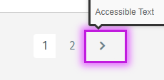

Issue Number | Accessibility 7
Issue | Elements must only use allowed ARIA attributes
Link | https://app-bldenrgy-ermx-iar-portal-ae-sit.azurewebsites.net/survey/td-testing-publishing  Applies to all accordions
Impact | Using ARIA attributes in roles where they are not allowed can interfere with the accessibility of the web page. Using an invalid role-attribute combination will, at best, result in no effect on the accessibility of the application and, at worst, may trigger behavior that disables accessibility for entire portions of an application.  When ARIA attributes are used on HTML elements that are not in accordance with WAI-ARIA 1.1, they conflict with the semantics of the elements which can cause assistive technology products report nonsensical user interface (UI) information that does not represent the actual UI of the document.
Severity | Critical
Required Correction | Ensures ARIA attributes are allowed for an element's role  Element location  #heading-additional_info  Element source  <div class="card-header " id="heading-additional_info" data-toggle="collapse" data-target="#card-body-additional_info" aria-expanded="True" aria-controls="card-body-additional_info">  To solve this issue, you need to...  Fix the following:  ARIA attribute is not allowed: aria-expanded="True"  Comment  Please follow ARIA practices for accordions. https://www.w3.org/WAI/ARIA/apg/patterns/accordion/
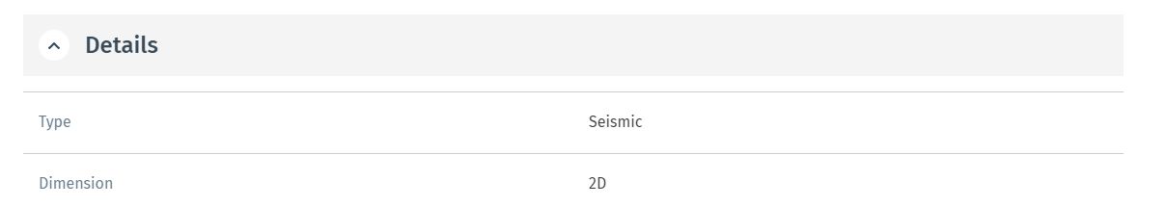

Issue Number | Accessibility 8
Issue | Elements must only use allowed ARIA attributes
Link | https://app-bldenrgy-ermx-iar-portal-ae-sit.azurewebsites.net/survey/td-testing-publishing  Applies to all accordions
Impact | Using ARIA attributes in roles where they are not allowed can interfere with the accessibility of the web page. Using an invalid role-attribute combination will, at best, result in no effect on the accessibility of the application and, at worst, may trigger behavior that disables accessibility for entire portions of an application.  When ARIA attributes are used on HTML elements that are not in accordance with WAI-ARIA 1.1, they conflict with the semantics of the elements which can cause assistive technology products report nonsensical user interface (UI) information that does not represent the actual UI of the document.
Severity | Critical
Required Correction | Ensure ARIA attributes are allowed for an element's role  Element location  #card-body-package-resources  Element source  <div id="card-body-package-resources" class="card-body collapse in" aria-labelledby="heading-package-resources" data-parent="#card-body-package-resources">  To solve this issue, you need to...  Fix the following:  aria-labelledby attribute is not well supported on a div with no valid role attribute.  Comment  Issue relates to accordion construction. Please follow ARIA practices https://www.w3.org/WAI/ARIA/apg/patterns/accordion/
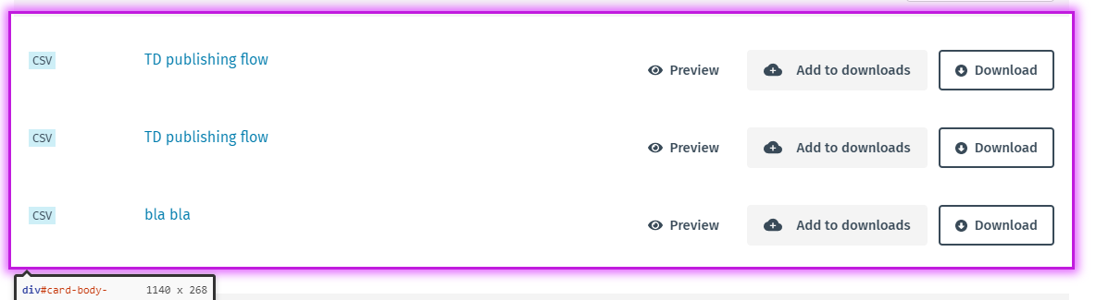

Issue Number | Accessibility 9
Issue | Buttons must have discernible text
Link | https://app-bldenrgy-ermx-iar-portal-ae-sit.azurewebsites.net/survey/td-testing-publishing
Impact | Screen reader users are not able to discern the purpose of elements with role="link", role="button", or role="menuitem" that do not have an accessible name.
Severity | Critical
Required Correction | Ensures buttons have discernible text  Element location  #heading-activity > .card-header__title > .btn-white.btn-round.btn-accordion  Element source  <button class="btn btn-white btn-round btn-accordion">  To solve this issue, you need to...  Fix at least one (1) of these issues:  - Element does not have inner text that is visible to screen readers  - aria-label attribute does not exist or is empty  - aria-labelledby attribute does not exist, references elements that do not exist or references elements that are empty  - Element has no title attribute  - Element's default semantics were not overridden with role="none" or role="presentation"  Comment  Please follow ARIA practices for accordions as listed above.
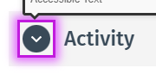

Issue Number | Accessibility 10
Issue | Links with the same name must have a similar purpose
Link | https://app-bldenrgy-ermx-iar-portal-ae-sit.azurewebsites.net/survey/td-testing-publishing  https://app-bldenrgy-ermx-iar-portal-ae-sit.azurewebsites.net/ckan-admin/search-queries  Applies to many areas of the site
Impact | This rule is important because the intention is to help users understand the purpose of each link in the content, so they can decide whether they want to follow it. Best practice is that links with the same destination would have the same descriptions, but links with different purposes and destinations would have different descriptions (see also Success Criterion 3.2.4 which calls for consistency in identifying components that have the same functionality). Because the purpose of a link can be identified from its link text, links can be understood when they are out of context, such as when the user agent provides a list of all the links on a page.
Severity | Medium
Required Correction | Ensure that links with the same accessible name serve a similar purpose  Element location  .resource-item:nth-child(1) > .download-col.hidden-xs.hidden-sm:nth-child(3) > .btn-trans-to-gray.with-icon.btn  Element source  <a href="/dataset/td-testing-publishing/resource/a796e688-1313-4f7a-9077-35e30ec48b33" class="btn btn-trans-to-gray with-icon">  To solve this issue, you need to...  Fix the following:  Check that links have the same purpose, or are intentionally ambiguous.  Related nodes:  .resource-item:nth-child(2) > .download-col.hidden-xs.hidden-sm:nth-child(3) > .btn-trans-to-gray.with-icon.btn  .resource-item:nth-child(3) > .download-col.hidden-xs.hidden-sm:nth-child(3) > .btn-trans-to-gray.with-icon.btn  Comment  Ensure all links to different destinations have a unique accessible name.
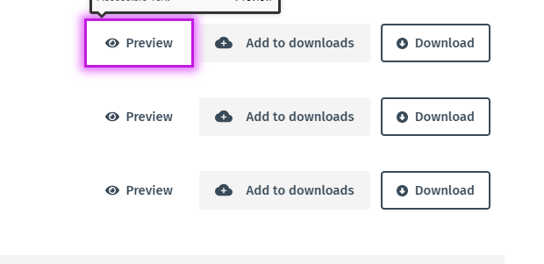
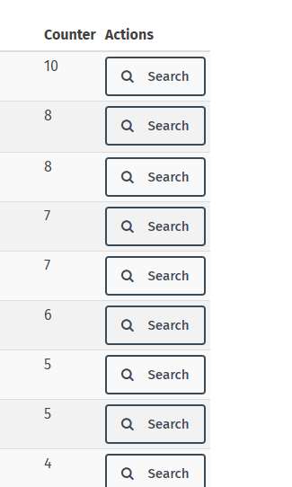

Issue Number | Accessibility 11
Issue | Form elements must have labels
Link | https://app-bldenrgy-ermx-iar-portal-ae-sit.azurewebsites.net/dataset/  Applies to dialog modal fields
Impact | Effective form labels are required to make forms accessible. The purpose of form elements such as checkboxes, radio buttons, input fields, etcetera, is often apparent to sighted users, even if the form element is not programmatically labeled. Screen readers users require useful form labels to identify form fields. Adding a label to all form elements eliminates ambiguity and contributes to a more accessible product.  When labels for form elements are absent, screen reader users do not know the input data expectations. Screen readers cannot programmatically determine information about input objects without an established label relationship (or redundant text serving as a label).  The absence of labels prevent fields from receiving focus when read by screen readers, and users with impaired motor control do not get the benefit of a larger clickable area for the control since clicking the label activates the control.
Severity | Critical
Required Correction | Ensure every form element has a label  Element location  #west-lng  Element source  <input type="number" step="0.1" id="west-lng">  To solve this issue, you need to...  Fix at least one (1) of these issues:  Form element does not have an implicit (wrapped) <label>  - Form element does not have an explicit <label>  - aria-label attribute does not exist or is empty  - aria-labelledby attribute does not exist, references elements that do not exist or references elements that are empty  - Element has no title attribute  - Element has no placeholder attribute  - Element's default semantics were not overridden with role="none" or role="presentation"  Comment  Add field label.
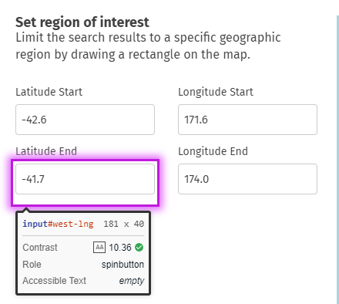

Issue Number | Accessibility 12
Issue | Buttons must have discernible text
Link | https://app-bldenrgy-ermx-iar-portal-ae-sit.azurewebsites.net/dataset/
Impact | Screen reader users are not able to discern the purpose of elements with role="link", role="button", or role="menuitem" that do not have an accessible name.
Severity | Critical
Required Correction | Ensures buttons have discernible text  Element location  .navbar-toggle  Element source  <button data-target="#main-navigation-toggle" data-toggle="collapse" class="navbar-toggle collapsed" type="button">  <span class="fa fa-bars"></span>  </button>  To solve this issue, you need to...  Fix at least one (1) of these issues:  - Element does not have inner text that is visible to screen readers  - aria-label attribute does not exist or is empty  - aria-labelledby attribute does not exist, references elements that do not exist or references elements that are empty  - Element has no title attribute  Element's default semantics were not overridden with role="none" or role="presentation"  Comment  Please add off screen text for the menu. Not all screen readers can read ARIA labels.
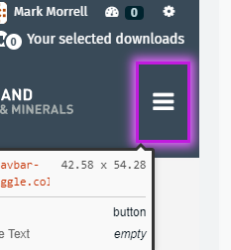

Issue Number | Accessibility 13
Issue | ARIA attributes must conform to valid values
Link | https://app-bldenrgy-ermx-iar-portal-ae-sit.azurewebsites.net/download-cart/check-out
Impact | ARIA attributes (i.e. starting with aria-) must contain valid values. These values must be spelled correctly and correspond to values that make sense for a particular attribute to perform the intended accessibility function.  Many ARIA attributes accept a specific set of values. Allowed values, acceptable "undefined" values, and acceptable "default" values are required. Failure to comply with allowed values results in content that is not accessible to assistive technology users.
Severity | Critical
Required Correction | Ensures all ARIA attributes have valid values  Element location  .mbie_erm-ds-item:nth-child(1) > .dataset-item-bottom > .resource-list-selected[role="button"][aria-controls="collapseExample"]  Element source  <div class="resource-list-selected" data-toggle="collapse" href="#28fd10af-779a-4c22-9e6c-8b075c5a521c" role="button" aria-expanded="true" aria-controls="collapseExample">  Resources size to download:  <span class="resources-size">0 B</span>  </div>  To solve this issue, you need to...  Fix the following:  Invalid ARIA attribute value: aria-controls="collapseExample"  Comment  Please follow ARIA practices for accordions.
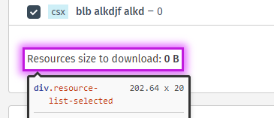

  - Contrast and responsive design issues
The following Contrast issues have been identified according to the AA specifications in https://www.w3.org/TR/WCAG21/#distinguishable
WCAG 2.1 level AA requires a contrast ratio of 4.5:1 for normal text and 3:1 for large text. Large text is defined as 14 point (typically 18.66px) and bold or larger, or 18 point (typically 24px) or larger.
Issue Number | Accessibility 14
Issue | Using images or gradients as backgrounds with text over the top
Link | https://app-bldenrgy-ermx-psc-portal-ae-sit.azurewebsites.net/dataset/  https://app-bldenrgy-ermx-iar-portal-ae-sit.azurewebsites.net/dashboard/
Impact | User may not be able to see the text
Severity | Major
Required Correction | Special care needs to be taken when using images or gradients as backgrounds with text over the top. Ensure that the correct contrast ratio is maintained across the entire text no matter what screen resolution, orientation, device or zoom is used.  Please ensure the text never overlaps the left image.


Issue Number | Accessibility 15
Issue | The white on red doesn’t meet contrast ratio standards
Link | https://app-bldenrgy-ermx-iar-portal-ae-sit.azurewebsites.net/user/edit/mark-morrell-1489
Impact | User may not be able to see the text
Severity | Major
Required Correction | The white on red (#EB2027) has a contrast ratio of 4.4:1 which fails contrast ratio standards for normal text sizes.  Current size 15px  level AA requires a contrast ratio of at least 4.5:1 for normal text and 3:1 for large text. Large text is defined as 14 point (typically 18.66px) and bold or larger, or 18 point (typically 24px) or larger.  Correct in all locations used.  The number 2 also fails with a ratio of 2.21
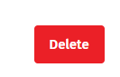

Issue Number | Accessibility 16
Issue | The red on white doesn’t meet contrast ratio standards
Link | https://app-bldenrgy-ermx-iar-portal-ae-sit.azurewebsites.net/user/edit/mark-morrell-1489  Applies to all required field markers
Impact | User may not be able to see the text
Severity | Major
Required Correction | The red (#C6898B) on white has a contrast ratio of 2.85:1 which fails contrast ratio standards for all text sizes.  Current size 16px  level AA requires a contrast ratio of at least 4.5:1 for normal text and 3:1 for large text. Large text is defined as 14 point (typically 18.66px) and bold or larger, or 18 point (typically 24px) or larger.  Correct in all locations used.  The number 2 also fails with a ratio of 2.21


Issue Number | Accessibility 17
Issue | The grey on grey doesn’t meet contrast ratio standards
Link | https://app-bldenrgy-ermx-iar-portal-ae-sit.azurewebsites.net/dataset/new  https://app-bldenrgy-ermx-iar-portal-ae-sit.azurewebsites.net/submission/new
Impact | User may not be able to see the text
Severity | Major
Required Correction | The grey (#AEAEAE) on green (#EDEDED) has a contrast ratio of 1.89:1 which fails contrast ratio standards for all text sizes.  Current size 16px  level AA requires a contrast ratio of at least 4.5:1 for normal text and 3:1 for large text. Large text is defined as 14 point (typically 18.66px) and bold or larger, or 18 point (typically 24px) or larger.  Correct in all locations used.  The number 2 also fails with a ratio of 2.21


Issue Number | Accessibility 18
Issue | The white on green doesn’t meet contrast ratio standards
Link | https://app-bldenrgy-ermx-iar-portal-ae-sit.azurewebsites.net/dataset/new  https://app-bldenrgy-ermx-iar-portal-ae-sit.azurewebsites.net/submission/new
Impact | User may not be able to see the text
Severity | Major
Required Correction | The white (#697C8A) on green (#8CC68A) has a contrast ratio of 1.98:1 which fails contrast ratio standards for all text sizes.  Current size 16px  level AA requires a contrast ratio of at least 4.5:1 for normal text and 3:1 for large text. Large text is defined as 14 point (typically 18.66px) and bold or larger, or 18 point (typically 24px) or larger.  Correct in all locations used.


Issue Number | Accessibility 19
Issue | The blue on grey doesn’t meet contrast ratio standards
Link | https://app-bldenrgy-ermx-iar-portal-ae-sit.azurewebsites.net/submission
Impact | User may not be able to see the text
Severity | Major
Required Correction | The blue (#697C8A) on grey (#F4F4F4) has a contrast ratio of 3.93:1 which fails contrast ratio standards for normal text sizes.  Current size 16px  level AA requires a contrast ratio of at least 4.5:1 for normal text and 3:1 for large text. Large text is defined as 14 point (typically 18.66px) and bold or larger, or 18 point (typically 24px) or larger.  Correct in all locations used.

Issue Number | Accessibility 20
Issue | The blue on grey doesn’t meet contrast ratio standards
Link | https://app-bldenrgy-ermx-iar-portal-ae-sit.azurewebsites.net/dataset/?q=testing&ext_bbox=&ext_prev_extent=
Impact | User may not be able to see the text
Severity | Major
Required Correction | The blue (#007CAD) on grey (#F4F4F4) has a contrast ratio of 4.25:1 which fails contrast ratio standards for normal text sizes.  Current size approx 10px  level AA requires a contrast ratio of at least 4.5:1 for normal text and 3:1 for large text. Large text is defined as 14 point (typically 18.66px) and bold or larger, or 18 point (typically 24px) or larger.  Correct in all locations used.


Issue Number | Accessibility 21
Issue | The grey on white doesn’t meet contrast ratio standards
Link | https://app-bldenrgy-ermx-iar-portal-ae-sit.azurewebsites.net/dashboard/  https://app-bldenrgy-ermx-iar-portal-ae-sit.azurewebsites.net/
Impact | User may not be able to see the text
Severity | Major
Required Correction | The grey (#697C8A) on white has a contrast ratio of 4.32:1 which fails contrast ratio standards for normal text sizes.  Current size approx 10px  level AA requires a contrast ratio of at least 4.5:1 for normal text and 3:1 for large text. Large text is defined as 14 point (typically 18.66px) and bold or larger, or 18 point (typically 24px) or larger.  Correct in all locations used.
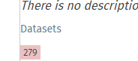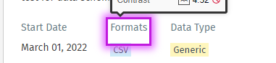

Issue Number | Accessibility 22
Issue | The grey on white doesn’t meet contrast ratio standards
Link | https://app-bldenrgy-ermx-iar-portal-ae-sit.azurewebsites.net/dashboard/
Impact | User may not be able to see the text
Severity | Major
Required Correction | The grey (#777777) on white has a contrast ratio of 4.47:1 which fails contrast ratio standards for normal text sizes.  Current size 14px  level AA requires a contrast ratio of at least 4.5:1 for normal text and 3:1 for large text. Large text is defined as 14 point (typically 18.66px) and bold or larger, or 18 point (typically 24px) or larger.  Correct in all locations used.
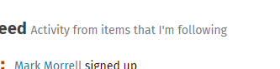

Issue Number | Accessibility 23
Issue | The grey on white doesn’t meet contrast ratio standards
Link | https://app-bldenrgy-ermx-iar-portal-ae-sit.azurewebsites.net/dashboard/
Impact | User may not be able to see the text
Severity | Major
Required Correction | The grey (#999999) on white has a contrast ratio of 2.84:1 which fails contrast ratio standards for normal text sizes.  Current size 12px  level AA requires a contrast ratio of at least 4.5:1 for normal text and 3:1 for large text. Large text is defined as 14 point (typically 18.66px) and bold or larger, or 18 point (typically 24px) or larger.  Correct in all locations used.


Issue Number | Accessibility 24
Issue | The grey on grey doesn’t meet contrast ratio standards
Link | https://app-bldenrgy-ermx-iar-portal-ae-sit.azurewebsites.net/dashboard/
Impact | User may not be able to see the text
Severity | Major
Required Correction | The grey (#737475) on grey (#F4F4F4)has a contrast ratio of 4.25:1 which fails contrast ratio standards for normal text sizes.  Current size 12px  level AA requires a contrast ratio of at least 4.5:1 for normal text and 3:1 for large text. Large text is defined as 14 point (typically 18.66px) and bold or larger, or 18 point (typically 24px) or larger.  Correct in all locations used.
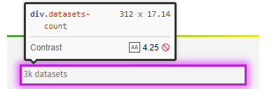

  - Keyboard Issues
The following Keyboard navigation issues have been identified according to the AA specifications in https://www.w3.org/TR/WCAG21/#keyboard-accessible.

Issue Number | Accessibility 25
Issue | Skip links missing
Link | All pages
Impact | User will not be able to skip to main areas of the page easily
Severity | Major
Required Correction | Please add the below skip links  - Skip to navigation  - Skip to content  - Skip to search

Issue Number | Accessibility 26
Issue | Content accessible behind dialog modals
Link | https://app-bldenrgy-ermx-iar-portal-ae-sit.azurewebsites.net/dashboard/datasets  Affects all site modal dialogs
Impact | User will find it difficult to know where they are
Severity | Critical
Required Correction | User after activating the dialog modal has to navigate past all the greyed out (lightbox) content to access the modal.  Please follow ARIA practices for modal dialogs  https://www.w3.org/WAI/ARIA/apg/patterns/dialogmodal/
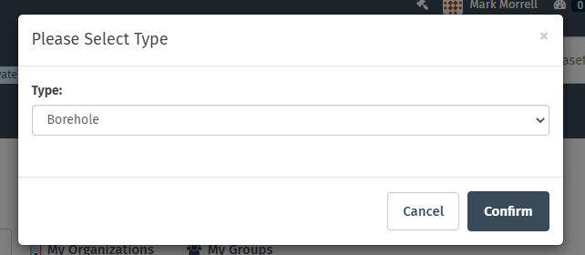

Issue Number | Accessibility 27
Issue | Unable to add date
Link | https://app-bldenrgy-ermx-iar-portal-ae-sit.azurewebsites.net/report/new
Impact | User will not be able to submit the forms
Severity | Blocker
Required Correction | The date picker is inaccessible via keyboard and you can’t enter a date manually.  Ensure a date can be entered manually.
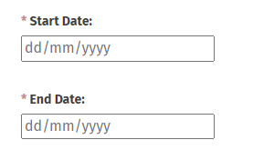

Issue Number | Accessibility 28
Issue | Unable to activate upload button using keyboard
Link | https://app-bldenrgy-ermx-iar-portal-ae-sit.azurewebsites.net/report/testing-accessibility/resource/new  https://app-bldenrgy-ermx-iar-portal-ae-sit.azurewebsites.net/user/edit/mark-morrell-1489  Applies to all upload fields
Impact | User will not be able to upload a file
Severity | Blocker
Required Correction | Ensure pressing enter when the button has focus opens the users file system.
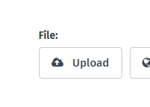

Issue Number | Accessibility 29
Issue | Tab focus bounding box missing from multiple elements
Link | https://app-bldenrgy-ermx-iar-portal-ae-sit.azurewebsites.net/dataset/?q=id%3A%28f9c7f7f0-df96-5812-8cff-1f22bc0bd373+or+ac82640e-b620-59aa-829e-26eb2e811f40+or+515086fa-5278-5e3c-999c-62d9bdb14b35%29
Impact | User will lose position on screen.
Severity | Critical
Required Correction | Please see WCAG 2.0 2.4.7 https://www.w3.org/TR/UNDERSTANDING-WCAG20/navigation-mechanisms-focus-visible.html  See screenshots in notes below: The current focus needs to be visible on these elements by either altering its appearance with CSS (to show focus) or allowing the browser to display the default bounding box around the focusable elements.  Please also note https://www.w3.org/WAI/WCAG22/Understanding/focus-appearance-minimum.html
Mobile hamburger menu

Checkbox
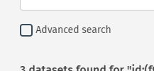
Bounding box missing from the below also doesn’t seem to appear in the tab order of the page.
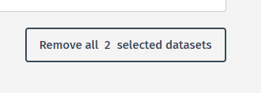

Issue Number | Accessibility 30
Issue | Unable to use select boxes using a keyboard
Link | https://app-bldenrgy-ermx-iar-portal-ae-sit.azurewebsites.net/dataset/?q=testing&ext_bbox=&ext_prev_extent=&vocab_report_commodity=Gold
Impact | User will not be able to use the select boxes
Severity | Critical
Required Correction | I can open the select box but I can’t select any of the options. Please be sure semantic HTML to construct the select boxs.  https://www.w3schools.com/tags/tag_select.asp
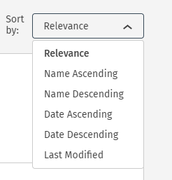

Issue Number | Accessibility 31
Issue | Checkboxes do not appear in tab order of the page
Link | https://app-bldenrgy-ermx-iar-portal-ae-sit.azurewebsites.net/download-cart/check-out
Impact | User will not be able to unselect some items
Severity | Critical
Required Correction | Ensure all elements which require focus to operate appear in the tab order of the page.  Please use semantic HTML for checkboxes. Ensure they are grouped in a fieldset with legend tag.
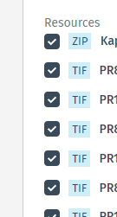

  - NVDA Issues
NVDA has been chosen as the standard for the testing for Screen readers. Using NVDA the following issues have been found.
Issue Number | Accessibility 32
Issue | NZ government logo
Link | All pages in footer
Impact | Wrong logo
Severity | Major
Required Correction | Needs to NZ government logo. Ensure that the new logo mouri words have the correct language markup. See below example with span tag above with correct language tag.
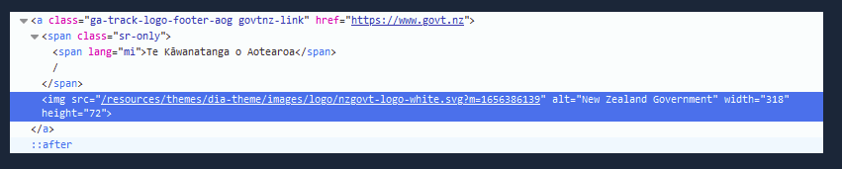

Issue Number | Accessibility 33
Issue | If Recaptcha is used anywhere
Link | https://app-bldenrgy-ermx-iar-portal-ae-sit.azurewebsites.net/dataset/?q=testing&ext_bbox=&ext_prev_extent=&ext_or_facet_extra_or_type=on
Impact | Deaf blind will not be able complete the form
Severity | Critical
Required Correction | Please change any version 2 checkbox reCAPTCHA to version 3.  https://www.digital.govt.nz/standards-and-guidance/design-and-ux/accessibility/captcha-and-accessibility/

Issue Number | Accessibility 34
Issue | Check boxes read as links
Link | https://app-bldenrgy-ermx-iar-portal-ae-sit.azurewebsites.net/dataset/?q=testing&ext_bbox=&ext_prev_extent=&ext_or_facet_extra_or_type=on  Applies to all links made to look like checkboxes
Impact | User will not know that they are checkboxes
Severity | Critical
Required Correction | Please ensure you use semantic HTML markup for all fields.  https://www.w3schools.com/tags/att_input_type_checkbox.asp
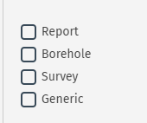

Issue Number | Accessibility 35
Issue | Changes to page do not alert the user
Link | https://app-bldenrgy-ermx-iar-portal-ae-sit.azurewebsites.net/dataset/?q=testing&ext_bbox=&ext_prev_extent=&ext_or_facet_extra_or_type=on  https://app-bldenrgy-ermx-iar-portal-ae-sit.azurewebsites.net/report/new  https://app-bldenrgy-ermx-iar-portal-ae-sit.azurewebsites.net/report/testing-nvda?__no_cache__=True
Impact | User will not know what has changed
Severity | Major
Required Correction | Please ensure if there are in page updates that they are contained in an ARIA live polite region so the user knows when they are updated.
Applies to all in page search fields
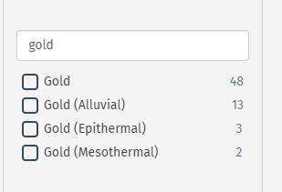
Applies to all error messages
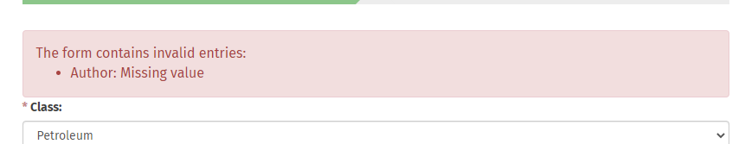
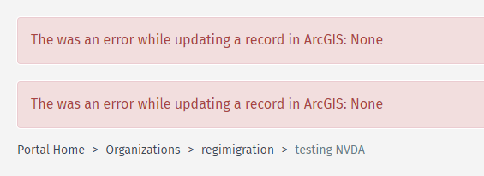

Issue Number | Accessibility 36
Issue | Close button not read a such
Link | https://app-bldenrgy-ermx-iar-portal-ae-sit.azurewebsites.net/report/testing-nvda?__no_cache__=True
Impact | User will not know what it is for
Severity | Medium
Required Correction | Ensure that the close error message button is read to the user as such. Use off screen text or ARIA label if this is not possible.
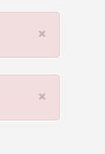

Issue Number | Accessibility 37
Issue | Graphic read to user
Link | https://app-bldenrgy-ermx-iar-portal-ae-sit.azurewebsites.net/survey/td-testing-publishing
Impact | Needless information read to user
Severity | Medium
Required Correction | Remove link from download graphic, makup as per other buttons e.g. below  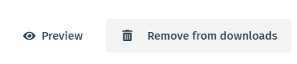


Issue Number | Accessibility 38
Issue | Edit button read with no context
Link | https://app-bldenrgy-ermx-iar-portal-ae-sit.azurewebsites.net/dataset/new
Impact | User will not know what they are editing
Severity | Medium
Required Correction | Add more detail to the button description, e.g. edit suggested URL button.
